



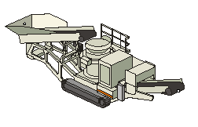





|  |  |  |  |  |  |
| --- | --- | --- | --- | --- | --- |
| Model: | 4 ¼ Symons  Short Head | Serial No. | 4714 | Date:  Hours | 3/16/2016 |

**Work Performed**

* Disassembled and inspected
* Refitted countershaft box bores, epoxy filler
* Replaced countershaft box seal
* Replaced CS box oil collar housing
* Checked bushing dimensions, within allowable tolerance
* Replaced sealing ring springs, housings, felt and locking keys
* Reset the gears to OEM spec
* Refitted socket assembly, oversized socket to fit the bore
* Replaced gaskets on the countershaft housing cover
* Installed new liners, short head fine liners
* Hard piped lube oil plumbing with new relief valve
* Flushed all contaminants with diesel fuel
* Test ran and painted